Instruction Manual
(使用说明书）
YTF-60、100、150-Z Stainless steel shockproof pressure gauges
YTF-60、100、150 Stainless steel pressure gauges
YTN-60、100、150 Shock proof pressure gauges
（YTF-60、100、150-Z型全不锈钢耐震压力表，YTF-60、100、150型全不锈钢压力表，YTN-60、100、150型耐震压力表）

一，Application
The measuring system, case,cover and gear rotating mechanism the Stainless steel pressure gauges and stainless steel shockproof pressure gauges (hereinafter referred to as the instrument), so have two characteristics,medium corrosion and environmental corrosion resistance.since widely used in petroleum, chemical industry, metallurgy, power station, food and other industries.stainless steel shockproof pressure gauges can also be used for the place of violent vibration.
Stainless steel shockproof pressure gauges used in severe environment, measuring the pressure of corrosive liquid,gas and steam , the seal grade is IP65.
（一、用途
全不锈钢压力表和全不锈钢耐震压力表（以下简称仪表）的测量系统、表壳、表盖、齿轮传动机构均采用耐腐蚀性能良好的不锈钢材料制做，所以不仅具有介质腐蚀的特点，还具有耐环境腐蚀特点，从而广泛用于石油、化工、冶金、电站、食品等工业部门。全不锈钢耐震压力表还可用于环境震动剧烈的场所。
全不锈钢耐震压力表用于环境剧烈的场所，测量具有腐蚀作用的液体，气体和蒸汽的压力，其密封等级达IP65。）

二，Working Principles and Structure Features
The spring tube end will displacement when the measured medium entering
the spring tube.the displacement will be handed to the gear transmission mechanism by the rod, with that,the pointer will point out the pressure value on the dial of the measured medium .
The instrument is made up of case,cover, spring body parts, transmission mechanism, dial, pointer parts, meter glass, plug,etc.
（二、工作用原理及结构特点
当被测介质进入弹簧管内时、弹簧管末端产生位移，由拉杆将位移传至齿轮传动机构，通过指针把被测介质的压力值在刻度盘上指示出来。
仪表由表壳、表盖、弹簧体部件、传动机构、刻度盘、指针部件，表玻璃、塞等零部件组成。）

三，Specification
1、Case diameter：φ60、φ100、φ150
2、Accuracy class：1.0级、1.5级、2.5级
3、Range：（MPa)
(1) Pressure：0-0.1，0-0.16，0-0.25，0-0.4，0-0.6，0-1，0-1.6，0-2.5， 0-4，0-6，0-10，0-16，0-25，0-40，0-60
（2）Vacuum：-0.1-0
（3）Pressure vacuum：-0.1-0.06，-0.1-0.15，-0.1-0.3，-0.1-0.5，
-0.1-0.9，-0.1-1.5，-0.1-2.4
4、Temp range ：general type;-40-60℃ shockproof type：0-60℃
5、Connection threads.：M20×1.5 1/2"NPT ,1/4"NPT
6、Material ：stainless steel 316L
7、Pump medium：Silicone oil or transformer oil
1
8、The dimensions as shown in figure.

四,Acceptance and Storage :
1, after receipting the instrument, please check whether the packaging is intact, if there are any damage, find out the reason immediately!
2, after opening the package, lease check whether the instrument is in good condition.If there is any damage, notify our factory immediate
3, the instrument should be stored in a dry ventilated room.
（四、验收与保管
1、用户收到仪表后，应先检测包装是否完整无损，如有损坏，应立即查明原因。
2、打开包装，检查仪表是否完好。如有损坏，应立即通知我厂。
3、仪表应贮藏于干燥通风的室内。）
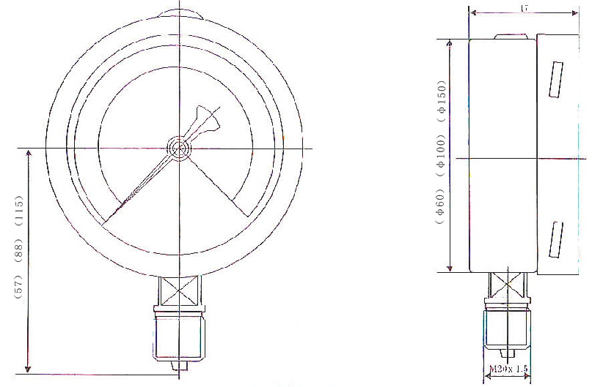
DWG :YTN-60、100、150 types；YTF-60、100、150types；
YTF-60、100、150-Z types
Drawing（for your information）

五，installation and usage
1, The instrument be allowed use range of full scale 1/3-3/4.
2, The instrument usage temperature for - 40-60 ℃ (general), 0 to 60 ℃ (shockproof), in this range from 20 + 5 ℃, should consider additional temperature difference, the coefficient of the temperature additional error is 0.04% ℃.
3, The header of the instrument should be installed vertically, for reading and maintenance.the installation site of the light is enough,
4,When damping oil is filled in the instrument , it can be used in the occasions of strong vibration, has great effect of shockproof,but by this time ,the indication is indicating a average is slightly lower than general use gauge indicates average, you should record the difference value for correction.
5, Please open the oil plug to aerate air when the shockproof pressure gauges have to be inspected and cut oil plug to ensure accuracy when the gauges are used.
6,The instrument must br practice test validation regularly, in order to ensure accurate indicating.
（安装与使用
1、仪表允许使用范围为满量程1/3-3/4。
2、仪表使用的环境温度为-40-60℃（普通型）、0-60℃（耐震性），在偏离20±5℃这个范围时，应考虑温度附加差，其温度附加误差系数为0.04%℃。
3、仪表表头应垂直安装，安装现场所应光线充足，以便读数和维护。
4、仪表内充有阻尼油时，可用于强烈震动的场合，具有良好的耐震效果，但此时仪表指示的平均值比一般用途压力表指示的平均值略有降低，用户使用时应记录此差值，以作校正。
5、耐震压力表检验时打开油堵必须与大气相通。使用时剪开油堵保证精度。
6、仪表应定期实习试制校验，以保证指示准确。）

六，Notice :
Please indicate the type, model name, measurement range, precision grade, and joint thread when you order it,
（六、订货须知
订货时必须注明型号、名称、测量范围、精度等级以及接头螺纹。）

